**Case report: Measurement of the optic nerve sheath in a patient with acute subdural hematoma in a Neurotrauma hospital.**

**Reporte de caso: Medición de la vaina del nervio óptico en paciente con hematoma subdural agudo en un hospital de Neurotrauma.**

**Abstract**

Introduction: Brain trauma: monitoring and treatment options currently constitute the paradigms for progress in survival. Early detection of increased intracranial pressure is incredibly important in minimizing the secondary injury; Simple, reproducible, non-invasive methods are needed, that can be performed at the patient's bedside.

Case presentation: This is a 29-year-old male patient with an acute left subdural hematoma, and left temporal parenchymal hemorrhage, in the emergency area the patient was intubated (Glasgow 6), and he is referred to our hospital for surgical management. After no responding to antiedema therapy, we developed a frontotemporal craniotomy to evacuate the hematoma.

Conclusions: Recently, the non-invasive intracranial pressure determination has gained interest, particularly the ultrasonographic optic`s nerve diameter measurement.

**Abstract**

Introducción: Traumatismo craneoencefálico: las opciones de seguimiento y tratamiento constituyen actualmente los paradigmas para avanzar en la supervivencia. La detección temprana del aumento de la presión intracraneal es increíblemente importante para minimizar la lesión secundaria; Se necesitan métodos simples, reproducibles, no invasivos, que se puedan realizar al lado de la cama del paciente.

Caso clínico: Se trata de un paciente masculino de 29 años con hematoma subdural agudo izquierdo, y hemorragia parenquimatosa temporal izquierda, en urgencias el paciente fue intubado (Glasgow 6), siendo derivado a nuestro hospital para manejo quirúrgico. Tras no responder a la terapia antiedema, se realizó una craneotomía frontotemporal para evacuar el hematoma.

Conclusiones: Recientemente, la determinación de la presión intracraneal no invasiva ha ganado interés, particularmente la medición ultrasonográfica del diámetro del nervio óptico.

**Keywords**: Optic Nerve, Intracranial Hypertension, subdural hematoma.

Palabras clave: nervio óptico, hipertensión intracraneal, hematoma subdural.

**Abbreviations**

**ONSD –** Optic nerve sheath diameter, **ICP**- intracranial pressure, **ONSD** Ultrasonography measurement of the optic nerve sheath diameter, **ICH** - intracranial hypertension

**Introduction**

Normal intracranial pressure (ICP) is 5 to 15 mmHg in adults, 3-7 mmHg in children, and 1.5-6 mmHg in infants. The Increment in intracranial pressure in a patient with brain trauma will depend on the integrity of brain compliance. When ICP is greater than 20 mmHg it is considered intracranial hypertension (ICH) and is an important cause of secondary injury, irreversible brain damage, or even death. After brain trauma, intracranial compliance may decrease due to cerebral edema or occupying lesions that result in increased ICP. Cerebral perfusion pressure (CPP) decreases as a result of inadequate oxygen extraction and secondary ischemic injury.

**Case presentation**.

This is a 29-year-old male patient, with no significant history and no relevant genetic information, who begins his current condition on June 6, 2022, presenting fall from his own height concussing himself on the cranial region, presenting seizures, and somnolence, then the ambulance took him to Zacatlan where they perform a CT finding an acute left subdural hematoma, left temporal parenchymal hemorrhage, in the emergency area the patient was intubated (Glasgow 6), and he is referred to our hospital for surgical management. After no responding to antiedema therapy, we developed a frontotemporal craniotomy to evacuate the hematoma.

**Diagnostic Approach**

At our hospital, a neurological examination was carried out, we found the patient with FOUR scale 4 points, intubated, clinical examination cannot be performed, brainstem reflexes present, anisocoria left pupil 6mm, right pupil 2mm. Optic nerve sheath diameter by ultrasound (ONSD) was measured, 5.2mm left, 3.5 mm right. Consecutively, a brain tomography was performed with the following findings: acute left subdural hematoma, left temporal parenchymal hemorrhage, midline shift displacement equals 8 mm, subdural hematoma diameter 9mm, and parenchymal hemorrhage 12 cc volume. (Figure 1)

We decided to perform a frontotemporal evacuation by craniotomy and leave the parenchymal hemorrhage intact. Upon admission with laboratory studies of leukocytes 21 000 x mm3, hemoglobin 13.6 g/dl, hematocrit 40.9%, platelets 222 000 x mm3. One day after the surgery we perform a tomography, improving the midline shift, with less edema (figure 2). We perform another brain tomography one week after with parenchymal bleeding reabsorption. Post-operative ONSD by ultrasound was measured indicative of a significative decrease 3.0mm left. (Figure 3)

**Discussion**

Intracranial pressure (ICP) is defined as the pressure within the skull and thus the pressure within the brain tissue and Cerebrospinal fluid. The increase in ICP may result from the primary lesion whose causes may be CSF obstruction, cerebral edema, vascular congestion, hematoma formation (epidural, subdural, intraparenchymal and intraventricular) among other causes, in our patient it had a combination of intraparenchymal bleeding, and acute subdural hematoma, with no response to antiedema therapy, hyperventilation, osmotherapy, diuretics, so the next step was surgical hematoma´s evacuation.

Increased ICP is known to be associated with worse outcomes, which has led to considerable interest in patients with severe brain trauma, early elevated intracranial pressure diagnosis is essential to prevent secondary injury. ICP elevation ≥20mmHg is associated with a poor prognosis in patients with brain trauma, especially in early stages, since ICP elevation at this stage is associated with a higher risk of secondary ischemic injury.1 There are different modalities of ICP measurement that can be invasive or non-invasive, each of which has different peculiarities and indications.

The ideal technique for measuring ICP is one that meets the following characteristics: Non-invasive and that can be performed at the patient's bedside, high sensitivity and specificity, without risk of complications, easily accessible in all health institutions and low cost.2 In our case, two measurements were taken, the initial brain tomography which demonstrated acute left subdural hematoma, left temporal parenchymal hemorrhage, midline shift displacement equals 8 mm, subdural hematoma diameter 9mm, and parenchymal hemorrhage 12 mm3 volume (figure 1), we also measured the optic nerve sheath diameter by tomography 5.2mm left, 3.5 mm right, and by ultrasound was 5.2mm left, 3.9mm right, both measurements concluding in intracranial hypertension.

In a 2014 case report they demonstrated similar optic nerve sheath measurements, they concluded that based on the scientific evidence the ONSD measurement is positioning as a qualitative non-invasive procedure to assess ICP in different situations, either in the brain trauma scenario or in other non-traumatic entities that course with elevation of the ICP. Based on the studies carried out, the ONSD cut-off point that correlates with a ICP above 20 mmHg is 5 mm.2 On the other hand Newman stated that measurements in excess of 4.0mm under 1 year of age and 4.5 mm in older people suggest abnormal dilatation of the optic nerve sheath, and intracranial hypertension should be suspected.3

Currently, ultrasound is used by several specialties in various monitoring situations, diagnosis and intervention. The measures of the ONSD correlate with measurements noninvasive and invasive of ICP and with the findings CT scans of the different brain lesions which may be the cause of the raised ICP.4 In our case we were able to perform the measurements mentioned before since we have in the intensive care unit a dedicated ultrasound to perform them, however not all hospitals have the resources or have a dedicated ultrasound to perform the ONSD´S measurement. As stated by Venkatakrishna, every critical care unit should have and ultrasound in neurocritical care.5

There are several ways to measure the increase in the ICP, some of them includes CT scan, MRI, ICP monitor, and lumbar puncture. However as some had stated before these tests are invasive, or associated with radiation exposure, or not readily available. Ultrasonography measurement of the optic nerve sheath diameter (ONSD) is proposed as a quick measure to identify the elevated cranial pressure.6

The way that the ONSD is measured also includes a challenge for the clinician for instance Robba stated that the most accurate approach was 3 mm behind the retina in both eyes with the patients in supine position. The final ONSD value was calculated by averaging four measured values which is different from the way Jeon did it in the temporal part of the closed upper eyelid, with coupling gel, they took two measurements on each eye in transverse plane.7 One of the greatest studies mentioned by Li-juan Wang, recruiting 316 patients, The mean ONSD for all participants was 3.95 +- 0.67 mm (median, 3.78 mm), for our patient as we stated before initially previous surgical decompression the right ONSD was within these parameters.8 We compared the ONSD from the initial ultrasound to the preoperative CT (figure 3), and found a correlation of 91%, that being said as stated by Islas, there’s no statistically significant difference between these techniques.9 In pediatric head trauma, the ONSD 3 mm successfully predict elevated ICP as stated by other authors, including all variations our patient had 5.2 mm in the left eye conclusive with ICP. 10 14 15

The ONSD has been used as a predictive score for mortality also, in 2013 they estimated on a computed tomography the risk to higher mortality, including values above 7.0mm, maybe in some years we will standardized our diagnosis criteria and use more effectively tools to make better decisions whether we perform or not a procedure. 11

On a different topic, for the parenchymal hemorrhage we decided not to do a procedure, as stated by Bullock, patients with Glasgow Coma Scale (GCS) scores of 6 to 8 with frontal or temporal contusions greater than 20 cm3 in volume with midline shift of at least 5 mm and/or cisternal compression on CT scan, and patients with any lesion greater than 50 cm3 in volume should be treated operatively, in our patient he had 12 mm3 of volume.12

In some critical units, if the resource is available and the patient condition allows it, an MRI will be one of the best studies to determine the ONSD, yet the time to perform it is a lot longer than the CT and ultrasound. When brain MRI is indicated, ONSD measurement on images obtained using routine sequences can provide a quantitative estimate of the likelihood of significant intracranial hypertension. 13

**Conclusion**

Raised ICP can occur in multiple clinical settings and is a common life-threatening condition. The invasiveness of the ‘gold standard’ devices for detecting raised ICP and the risk for severe complications (infection, hemorrhage, and malfunction) preclude their use in several situations. ONSD´s Ultrasound guided has gained interest in the last years, and may be a useful technique when the invasive methods are not available, as stated by our findings the ONSD is a direct pathway and correlate with intracranial hypertension, the values from the studies mentioned above associate with our patient, but in places that there is no ultrasound available the CT may be the initial study to measure the ONSD, there are just few studies comparing the CT to ultrasound, therefore in the next years may be more information available to study this vast field.

**Bibliography**

|  |  |
| --- | --- |
|  | 1. Greenberg MS. Handbook of Neurosurgery. Stuttgart, Alemania: Thieme; 2019. |

|  |  |
| --- | --- |
|  | 1. Raúl Carrillo Esper ÓIFR. Evaluación ultrasonográfica del diámetro de la vaina del nervio óptico (DVNO) para la medición de la presión intracraneana (PIC): a propósito de un caso. Gaceta Médica de México. 2014;150:165–70. |

|  |  |
| --- | --- |
|  | 1. W D Newman, A S Hollman, G N Dutton, R Carachi. Measurement of optic nerve sheath diameter by ultrasound: a means of detecting acute raised intracranial pressure in hydrocephalus. Br J Ophthalmol. 2002;86:1109–13.DOI 10.1136/bjo.86.10.1109 |

|  |  |
| --- | --- |
|  | 1. Tania Rojas-Murillo NO-G. Relación entre la medición por tomografía y ecografía del diámetro de la vaina del nervio óptico como estimador no invasivo de la presión intracraneal. Permanyer. 2022;90:236–41. DOI 10.24875/CIRU.20001199 |

|  |  |
| --- | --- |
|  | 1. Venkatakrishna Rajajee JLD-G. Critical Care Ultrasound Should Be a Priority First-Line Assessment Tool in Neurocritical Care. Critical Care Medicine. 2019;47:833–6. DOI 10.1097/CCM.0000000000003712 |

|  |  |
| --- | --- |
|  | 1. Kegel AKNS. Optic nerve sheath diameter sonography for the diagnosis of increased intracranial pressure: a systematic review and meta-analysis protocol. BMJ open [Internet]. 2017;7. Disponible en: <https://pubmed.ncbi.nlm.nih.gov/28801417/> DOI 10.1136/bmjopen-2017-016194 |

|  |  |
| --- | --- |
|  | 1. Chiara Robba GS. Optic nerve sheath diameter measured sonographically as non-invasive estimator of intracranial pressure: a systematic review and meta-analysis. intensive care. 2017;44:1284–94. DOI 10.1007/s00134-018-5305-7 |

|  |  |
| --- | --- |
|  | 1. Li-juan Wang YY. Noninvasive and quantitative intracranial pressure estimation using ultrasonographic measurement of optic nerve sheath diameter. Nature [Internet]. 2017; Disponible en: <https://www.nature.com/articles/srep42063> DOI 10.1038/srep42063 |

|  |  |
| --- | --- |
|  | 1. Lgvl FIÁ. Medición del diámetro de la vaina del nervio óptico por ultrasonografía versus tomografía simple de cráneo en pacientes con trauma craneoencefálico. Medicina critica. 2020;34(4):221–30. DOI: 10.35366/95877. 2. Sik Nihan, The role of sonographic optic nerve sheath diameter measurements in pediatric head trauma. Journal of Ultrasound. Società Italiana di Ultrasonologia in Medicina e Biologia (SIUMB) 2022. https://doi.org/10.1007/s40477-022-00676-1. 3. Legrand A, Jeanjean P, Delanghe F, Peltier J, Lecat B, Dupont H. Estimation of optic nerve sheath diameter on an initial brain computed tomography scan can contribute prognostic information in traumatic brain injury patients. Critical Care. 2013;17(2):R61. 4. Bullock MR, Chesnut R, Ghajar J, Gordon D, Hartl R, Newell DW, Servadei F, Walters BC, Wilberger J. Guidelines for the surgical management of traumatic brain injury. *Neurosurgery.*2006;58:S2–S62 5. Geeraerts T, Newcombe VFJ, Coles JP, Abate MG, Perkes IE, Hutchinson PJA, Outtrim JG, Chatfield DA, Menon DK. Use of T2-weighted magnetic resonance imaging of the optic nerve sheath to detect raised intracranial pressure. *Crit Care.*2008;1:R114 6. Sekhon MS, Griesdale DE, Robba C et al (2014) Optic nerve sheath diameter on computed tomography is correlated with simultaneously measured intracranial pressure in patients with severe traumatic brain injury. Intensive Care Med 40(9):1267–1274 7. Le A, Hoehn ME, Smith ME, Spentzas T, Schlappy D, Pershad J (2009) Bedside sonographic measurement of optic nerve sheath diameter as a predictor of increased intracranial pressure in children. Ann Emerg Med 53(6):785–791 |

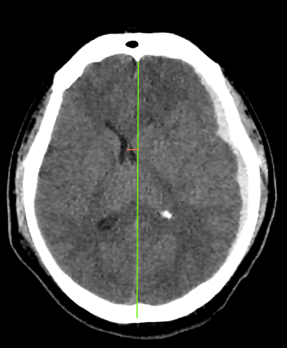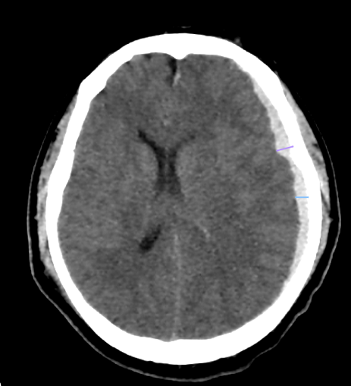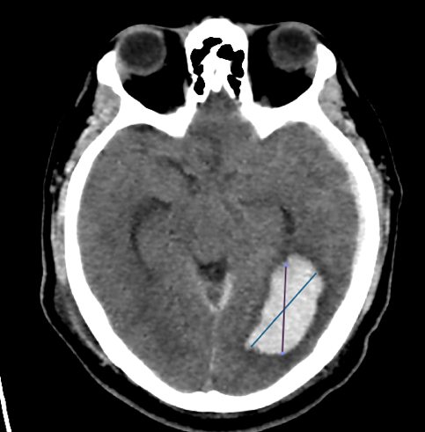

Figure 1. date: June 6 2022. Acute left subdural hematoma (white arrows), left temporal parenchymal hemorrhage, midline shift displacement equals 8 mm (green vertical line), subdural hematoma diameter 9mm (blue and purple line), and parenchymal hemorrhage 12 cc volume (yellow arrow)

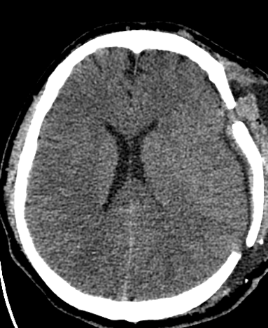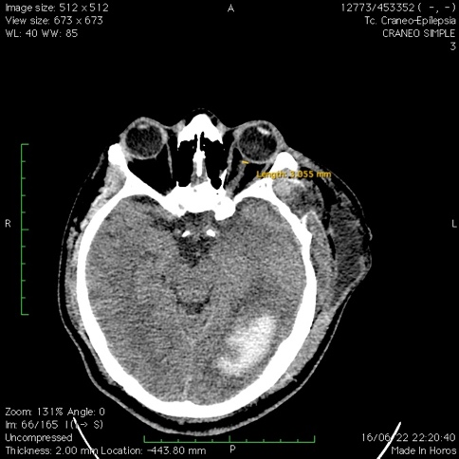

Figure 2: June 16 2022

Less edema, no midline displacement, optic nerve 3.055 mm left.

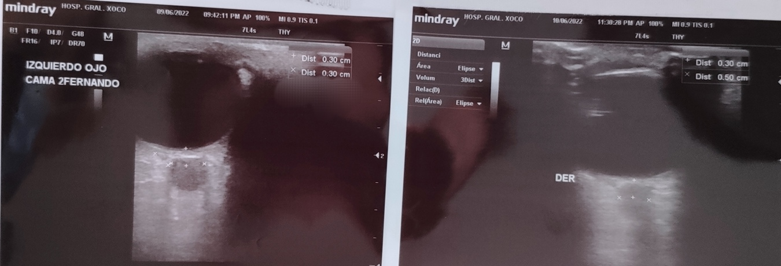

Figure 3

ONSD by ultrasound 1 day post-surgical decompression, with a decrement in the sheath diameter from 5.2 to 3.